

AIRPORT(airport_code,city,state,name)

AIRPLANE_TYPE(company, type_name, max_seats)

AIRPLANE(airplane_id, total_no_of_seats)

SEAT(seat_no)

LEG_INSTANCE(no_of_avail_seats, date)

FARES(code, amount, restrictions)

FLIGHT(number,airline,weekdays)

FLIGHT_LEG(leg_no)

FLIGHT 1 FARES n FARE





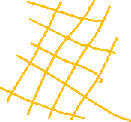

**- Ánh xạ kiểu thực thể yếu**

FARES(code, amount, restrictions)

FLIGHT(number,airline,weekdays)

🡪 FARE(number,code,airline,weekdays,amount,restrictions)

**- Ánh xạ thực thể yếu**

FARE(number,code,airline,weekdays,amount,restrictions)

FLIGHT_LEG(leg_no)

🡪 FLIGHT_LEG(number,code,leg_no,airline,weekdays,amount,restrictions)

FLIGHT_LEG

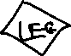



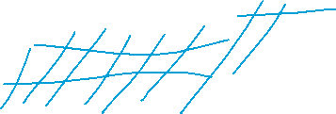

SEAT(seat_no)

LEG_INSTANCE(no_of_avail_seats, date)

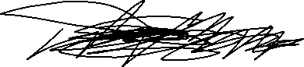

- Ánh xạ mối quan hệ 1 – nhiều

RESERVATION(seat_no,date,no_avail_seats,customer_name,cphone)